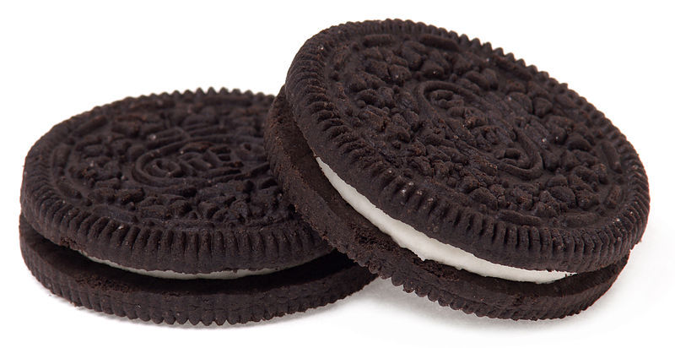LAB MAP for AP Investigation 00 – OREOS (modified from Dan Mott)

Directions: I will provide balances/scales, 5 Double-Stuff Oreos, 5 Regular Oreos, wax paper and a plastic knife to each Lab Team. Your team will design your lab based upon the claims put forth by Nabisco. Make a copy of this document and share with your team. It will be your rough draft for each of your individual Lab Notebooks.

5-Element Flowchart: I would get feedback from me on your flowchart (once you design it) before collecting data. Once your flowchart has been discussed, construct your data table BEFORE collecting any data.
AP Lab Rubric: Oreos: I strongly suggest that you read through the entire rubric, especially the “Professionalism” before starting.

1. Driving Question/Purpose: type

2. Background/Pre-Lab: (This is information that would help you decide your hypothesis and would demonstrate the rationale of any necessary derived calculations.) type

3. Hypothesis:
- If/then/because statement: type

- Variables identified: Independent (what you are varying): type

Dependent (what you are measuring): type

- Constants (what is the same for all aspects of the experiment): type

- Control (what you are comparing your independent variable to): type

4. Flowchart/Procedures: I would insert a picture of your five-element flowchart here - but BEFORE YOU DO - come and discuss your flowchart with me for feedback.
{insert picture of hand-drawn diagram}

5. Safety Considerations: type

6. Data Table Set-up: First column is the independent variable, followed by your dependent variable (data) and finally any derived calculations. Include any math calculations used for your derived calculations ( below your data table in your notebook – if appropriate.

Title: type

[NO GRAPH FOR THIS LAB]

7. Analysis C-E-R: These are complete sentences that highlight the information from the graphs. This would also include any statistical analysis (if done) as well as sources of error. It must include:
CLAIM (underlined in yellow): What trend do you see in your data? type
EVIDENCE (underline in blue): Include specifics from your data to support your claim(s). Don’t explain - just identify/list the quantitative. Was your data significant? type
REASON (underline in green): How does your evidence support your claim - what underlying scientific principle does your evidence support? This is where you explain your evidence. type
ERROR/UNCERTAINTY (underline in pink): Identify unavoidable error/uncertainties that might have affected your data. Be specific about its effects on your data. NO HYPOTHETICAL/HUMAN ERROR! If you make a mistake/error, during data collection, STOP, fix the problem, and then start again. If no unavoidable error occurred, write “No significant error occurred during this experiment.” type

8. Conclusions: A summary statement starting with, “Our data supports/does not support my hypothesis…” Answer what have you determined regarding the “Driving Question”. What could you do to reduce the experimental uncertainty? type

